### **Allbirds' Sustainable Footwear**

#### **1.Problem**

The footwear industry is a major contributor to climate change and a major cause to environmental problems the earth is facing. It is a sad fact that the footwear industry is responsible for 1.4% of global greenhouse gas emissions. To better put it into perspective this is close to the air travel sector with 2.5% of emissions and these are industries that shouldn't even be close in regard to environmental impact (González, 2024). This leads us to now examine the steps the footwear industry is taking to reduce these climate risks and how New Zealand is leading by example in addressing this problem. Promoting sustainable footwear takes us a step closer to a greener future and is essential for reducing environmental impacts. By focusing on eco-friendly materials, efficient production methods, sustainable distribution and transportation and waste reduction strategies we can reduce the effects of climate change.

**2.Product**

A product that will help solve the problem of climate change is Allbirds footwear, which is sustainable footwear that is made from sustainable materials like merino wool, eucalyptus, and sugarcane. This product will solve the problem of climate change as it will use renewable materials, regenerative agriculture, use sustainable transportation and distribution, and use responsible energy. Allbirds use renewable materials such as Merino wool which helps them use 60% less energy than materials used in typical synthetic shoes (allbirds.co.nz, n.d.). They also use Eucalyptus to create breathable, lightweight fabric as they use TENCEL™️ Lyocell which “uses 95% less water than conventional cotton and has a carbon footprint that is one-third lower than virgin nylon” (allbirds.co.nz, n.d.). Another renewable material they use is sugarcane which provides cushioning without relying on petroleum-based materials. They not only focus on the material they are using but also on their carbon emission as they invest in carbon removal projects that are connected to their value chain and are also trying to maximise their ocean shipping to reach their goal of “Achieving steady state of more than 95% ocean shipping” (allbirds.co.nz, n.d.).

**3.Vision statement**

We want to create lightweight, bouncy, and comfortable footwear whilst changing the footwear industry into becoming a more sustainable and eco-friendly industry. By creating eco-friendly products and using suitable distribution and transposition we hope to inspire a global movement towards a greener and healthier planet.

**4. customers and suppliers.**

**Suppliers:**

Allbirds footwear has a variety of suppliers. For their material suppliers they use ZQ Merino which Provides merino wool for Allbirds' shoes. Tencel which Supplies lyocell, a fibre made from sustainably sourced wood pulp. Sugarcane Farmers that provide the sugarcane used for their SweetFoam™ soles and Castor Oil Suppliers.

**Customers:**

Their customers include eco-conscious customers that prioritise sustainability. Their customers also include Athletes and active people who want comfortable lightweight footwear. Their customers also range out to minimalists that need simple and lightweight shoes.

**5.Industry analysis**

**Buyer power:**

Buyer power is high due to the availability of a lot of shoe brands offering similar products and the rise of eco-friendly sustainable footwear means that buyers will typically have a lot of options to choose from.

**Supplier power:**

supplier power is high. This is because sustainable materials like merino wool, sugarcane and Tencel are unique and not easily replaced which means that suppliers who provide these materials can negotiate prices and terms significantly, giving them the upper hand.

**Threat of substitutes:**

The threat of substitutes is high. Conventional footwear is often cheaper and therefore this option might bring consumers away from these pricey eco-friendly brands, particularly if conventional footwear offers similar performance or lower prices. Eco conscious consumers can just use other cheaper sustainable alternatives.

**Threat of new entrants:**

The threat of new entrants is low. This is because it is very expensive to maintain sustainability within the footwear industry as the technology/strategies and materials are pricey making it hard for new business to enter this industry.

**Rivalry among existing competitors:**

Rivalry is high. There is strong rivalry among existing and new brands in the sustainable footwear sector because of the constant innovations being made and the need for companies to differentiate themselves through their different sustainability practices and innovative designs.

**6.**

**Porter's generic strategy model**

Allbirds will adopt the differentiation strategy from porter’s generic strategies, to make sure that they remain competitive and constitute to lead the sustainable footwear industry.

Allbirds have adopted this strategy because of their focus on sustainable and eco-friendly materials. They have broad differentiation because of the materials and innovative products they use which makes them stand out and differentiate from other competitors such as merino wool, sugarcane and wood (eucalyptus). Not a lot of companies use these materials and by focusing on these unique products Allbirds will become very eye-catching to the eco-conscious individuals. In addition to this, Allbirds is very innovative with their own SweetFoam product made from sugarcane and their Plant leather products, offering something other marketplaces don't offer.

**7. value chain.**

**Value Chain**

1. **Inbound Logistics**: getting sustainable materials like eucalyptus,merino wool and sugarcane
2. **Operations**: Using Eco-friendly production and practices such as their innovative SweetFoam and Plant Leather and minimising waste
3. **Outbound Logistics**: Efficient, low-impact distribution such as using boats for overseas delivery instead of planes as they learn a carbon footprint.
4. **Marketing & Sales**: Highlighting sustainability in campaigns and making sure that they target eco-conscious individuals with targeted advertising.
5. **Service**: Supporting customers with a focus on eco-values and companies’ mission in mind.

**Supporting Activities**: Procurement, HR,Infrastructure and technology development.

**Opportunities for Cost Reduction**: improving production processes and distribution and using technology to enhance efficiency.

**8.Solution map composer**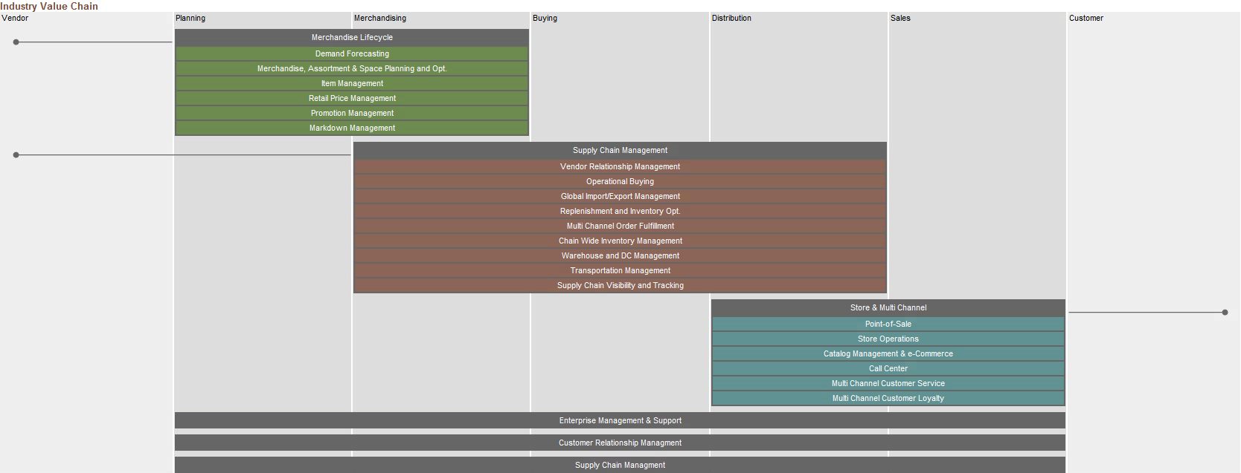

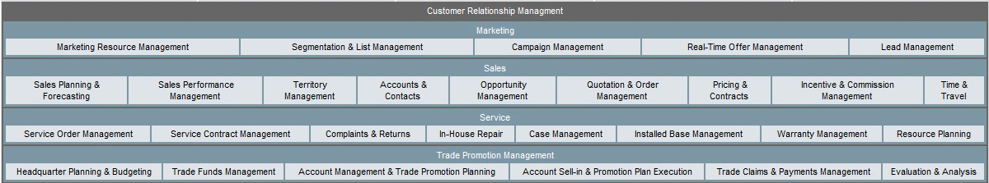

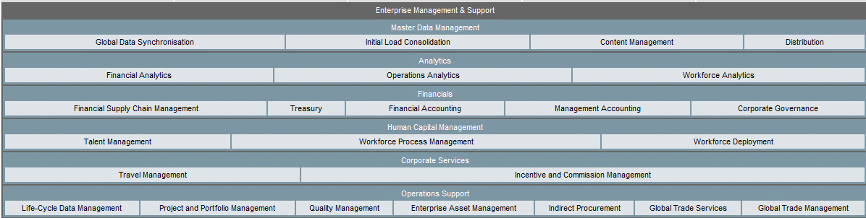

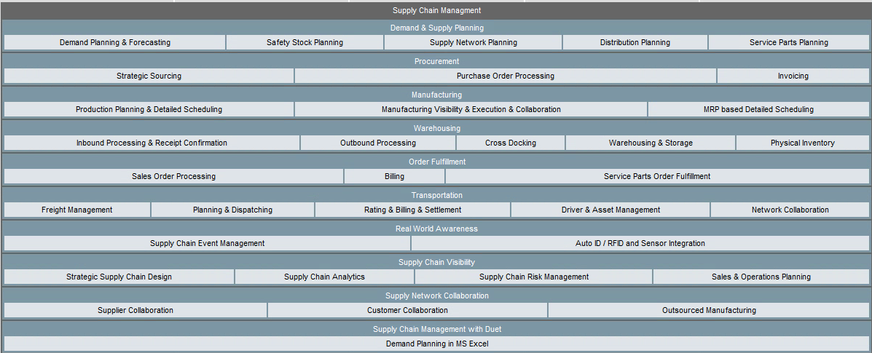

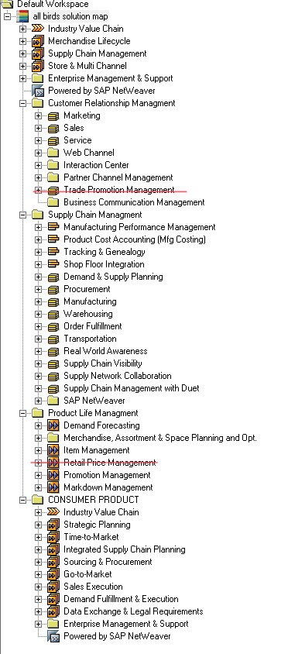

**Retail price management**

I removed retail price management because Allbirds is very consistent with their pricing strategy as they are a very high-end and expensive brand. They might not need to implement systems to manage retail prices as they have straightforward pricing and don't work with discounts and promotions much. Their pricing is more straightforward compared to traditional retailers.

**Trade promotion management**

I also removed trade promotion management. This is because Allbirds uses a direct-to-consumer model, meaning they don't sell to retailers and therefore do not need to implement complex systems such as trade promotion management as they

**9**.**business processes.**

**1. Sourcing Raw materials**

This process involves getting eco-friendly materials such as merino wool, eucalyptus and sugarcane and using them to produce sustainable footwear. Allbirds primary value regarding sustainability makes this a very crucial process and by using low-impact materials and ensuring traceability of these raw materials they will address the environmental issues in the footwear industry.

**2.Transportation (shipment tendering)**

This process is about managing the distribution of products from the manufacturing sites to the customers, while trying to minimise environmental effects. This means that Allbirds needs to consider choosing low-impact transportation methods and optimising supply chain logistics. To maintain Allbirds' commitment to sustainability they have used transportation methods like cargo shipping instead of planes, reducing their carbon footprint and showing their commitment to a greener

**10.Value chain Aris**



**11. AS-IS**

**TO be**

One of the improvements I made in my TO-BE diagram is installing fuel flow metres. By installing these fuel fuel metres I will be able to track fuel usage in real-time so that I can optimise efficient routes to reduce fuel consumption. With this real-time consumption data, the TO-BE process can now effectively measure and minimize the carbon footprint.

Another improvement I made in my TO-BE is by installing cargo monitoring. I did this so I can provide customers with tracking numbers so that they can monitor their packages in real-time.

This monitoring will provide regular updates on their package status and therefore enhance customer experience. This transparency will allow customers to feel more informed and in control of their deliveries. As a result, Customer Satisfaction Score (CSAT) is expected to rise, reflecting positive overall customer experience.

**References:**

González, T. (2024b, July 26). *The environmental impact of the footwear industry*. BEFLAMBOYANT. <https://www.beflamboyant.com/blogs/blog/the-environmental-impact-of-the-footwear-industry?country=ES>

allbirds.co.nz. (n.d.). *Our materials - wool*. https://www.allbirds.co.nz/pages/our-materials-wool